TEAM PROJECT REPORT
Catalytic Electrode Coatings for Removal of Pesticides from Drinking Water in Ozonation/Electrolysis Treatment Systems

Submitted To
The RET Site
For
“Challenge Based Learning and Engineering Design Process Enhanced Research Experiences for Middle and High School In-Service Teachers”

Sponsored By
The National Science Foundation
Grant ID No.: EEC-1404766

College of Engineering and Applied Science
University of Cincinnati, Cincinnati, Ohio

Prepared By
Ashley Gregory-Gray Middle School
Travis Hartberger-McKinley Technology High School

Approved By

Dr. Margaret Kupferle
Department of Environmental Engineering
College of Engineering and Applied Science
University of Cincinnati

Reporting Period: June 15-July 29, 2015
ABSTRACT
Mineralization of organic compounds, like atrazine, has been demonstrated separately via ozonation and electrolysis; however, this work details the assessment of catalysis on the synergistic ozonation/electrolysis degradation of atrazine. Manganese dioxide was evaluated as a heterogeneous catalyst on graphite by redox deposition and electrochemical deposition. The impact on the rate of degradation of atrazine was assessed two-fold: (1) quantitation of aqueous ozone using the indigo method, and (2) quantitation of atrazine and oxidation products using high-performance liquid chromatography (HPLC). Atrazine degradation was optimal at a current density of 10.0mA/cm² with a pseudo-zero order reaction rate of , with respect to atrazine. At current densities >20.0mA/cm², the ozonation/electrolysis synergism was less favored due to ozone stripping and current-limited mass transport. The application of MnO₂ as a suspended solid and as an anode and cathode, demonstrated limited to no improvement to the adsorption of and, subsequent, oxidation of atrazine by ozone. These findings are supported with featureless voltammograms of MnO₂-coated electrodes and chromatographic analysis. While studies have suggested higher oxides influence the ozonation pathway of ozonation/electrolysis synergism, this report uncovers manganese dioxide’s oxidant competition with ozone and no apparent change or improvement to the ozonation/electrolysis pathway to oxidize atrazine.

INTRODUCTION
One of the leading environmental issues facing the world today is the use of pesticides and herbicides in the agricultural industry. Although the use of these chemicals is common world-wide, 25% of overall pesticide application can be attributed solely to the United States. ¹ With the abundant amount of pesticides being used, exposure to these chemicals through drinking water and its effects on human health are significant issues that scientists have working to address.
Atrazine is one of the most common pesticides used worldwide. Most farmers use atrazine on crops such as sugar cane, macadamia nuts, and to help in the production of evergreen tree farms. Being an herbicide it can be applied in many forms including granular, liquid, or a powder composition. In order for atrazine to affect the plant (it most cases weeds), it must be dissolved in water and absorbed through the weed’s roots where it then stops the process of photosynthesis. Because atrazine is slow to degrade in water, once it enters a body of water such as a lake, stream, or pond, it tends to persist for long periods of time. ² Therefore atrazine is one of the most widespread pesticides found to linger in both surface and ground water systems. ³ There have been studies conducted that have found atrazine having unfavorable effects in humans who live or work near sites where the risk of atrazine exposure is high. ² One study found an increase in the risk of breast cancer in women and the puberty rate of adolescents. Research also links atrazine to disrupting the human reproductive system³. Although being exposed to pesticides later in life can still be detrimental to the reproductive hormones, the most predominant effects occur during the earliest stages of development. Women who come into contact with water contaminated with atrazine have been linked to having a higher risk of a premature birthrate. ³ Side effects found in animals include hormone disruption by the transformation of testosterone to estradiol and therefore the “feminizing” of animals is possible during this process.³
One treatment method for the degradation of pesticides (including atrazine) is the use of a combined system of electrolysis and ozonation. It has been found that when using electrolysis and ozonation combined for the degradation of phenolic pollutants, synergism may occur in the terms of total organic carbon (TOC) mineralization. ⁴ Synergism refers to a process in which when multiple methods are used simultaneously a greater output of the desired results are accomplished in comparison to the output of those methods being performed separately. In one particular study on the degradation of phenol, over 90% of TOC was removed from a p-nitrophenol (PNP) aqueous solution when using this synergetic system with a boron-doped diamond (BDD) anode. When compared to using electrolysis and ozonation systems separately, less than 50% of TOC was removed when the system was tested using the same reaction conditions. ⁴

One important component of a combined electrolytic/ozonation system is the current density which is applied to the reaction solution. Current density variation has been shown to have effects on TOC removal independent of the other variables in the reaction. In a study conducted by Feng and Xiao⁷, the results show that the rate of TOC removal for phenol increased with an increase in current density from 10 to 50mA/cm². Another study showed an increase in the atrazine degradation rate with increasing current density in an in situ electrochemical reaction ²⁵. The rate of ozone generation also increased within this system with a maximum rate of approximately 40 mg h⁻¹ for a current density of 1.5 kA m⁻². The degradation rate of atrazine followed a pseudo first-order kinetic equation in regards to the increasing current density, where the values of the rate constants were 6.2 × 10⁻³, 8.8 × 10⁻³, and 1.21 × 10⁻² min−1 for 0.5, 1.0, and 1.5 kA m⁻².²⁵ Therefore, using a combined method of electrolysis and ozonation along with a specific flow of current density within this system may be a feasible means for the efficient degradation of atrazine.
During ozonation, TOC mineralization has shown promise when using catalytic electrode coatings, especially those consisting of metal oxides. In a study centered around the degradation of phenol, the compound had been shown to be completely mineralized to carbon dioxide and water using a specific catalyzed anode within an electrolysis system ⁷. During this study, various metal-oxide coatings were tested on titanium electrodes in order to optimize the degradation of phenol in terms of time and TOC. Coatings were created with PbO₂ through electrochemical deposition and RuO₂ through thermal deposition and were tested to compare the TOC mineralization using cyclic voltammetry (CV). The oxygen evolution potential was shown be much higher in the Ti/PbO₂ electrode in comparison to the Ti/RuO₂, showing promise for organic oxidation of pollutants such as atrazine. It is also worthy to note that doping titanium with a rare earth metal such as Gd can also make electrochemical oxidation easier.⁷ Along with using lead oxide as a catalyst, there are an abundance of studies showing that manganese oxides also provide an increase in capacitance along the electrode surface and in some cases, the decomposition of ozone as well²⁶. Past research shows that the method of redox deposition for amorphous hydrous manganese dioxide (a-MnO₂·nH₂O) on graphite electrodes has shown promise in an electrolysis reaction chamber. Using CV analysis, there appears to be a logarithmic relationship in the results of the study, showing that as the deposition time of the MnO₂ (prepared by redox deposition) increases, the capacitance (mF/cm²) of the electrode increased as well²⁶. A study conducted by Hu and Tsou¹⁰ also discussed the production of an a-MnO₂·nH₂O solution on graphite electrodes (by means of anodic deposition) showing results of “ideal capacitive behavior” therefore showing promise on the advancement of electrochemical supercapacitor technology.¹⁰ Other studies have described using amorphous nano-structured manganese oxide coatings on stainless-steel electrodes as well (by means of electrochemical deposition). Using CV, these electrodes showed good reversibility and high capacitance, and the research concluded that the structure of the MnO₂ deposited on the electrodes (described in the study as porous) directly characterizes the capacitivity of the coating. ⁵ Catalysts consisting of MnO_{x} on mesoporous alumina (by method of wetness impregnation) provided evidence of the production of enhanced hydroxyl radicals during ozonation. These hydroxyl groups provide a higher catalytic rate of ozone decomposition as well as the degradation of the tested pharmaceutical compounds (those of which, like atrazine, are commonly found in surface and ground water). TOC results also showed a significant increase from 30% with ozonation alone to over 50% (under the constraints of pH 7.0, catalyst concentration of 1.5 g/L, and gaseous ozone concentration of 30 mg/L). ⁶ For the creation of catalytic coatings in this study, an ideal coating would produce an increased surface area on the anode, in hopes that the degradation rate of atrazine would be optimized as well as the ozone gas being produced. An increase in capacitance of the electrodes would be ideal for the goal of this study as well.

The goal of the research described herein was to optimize an ozonation/electrolytic treatment system for the removal of atrazine from drinking source waters. The first objective was to evaluate the changes in current density (mA/cm²) on the mechanism and rate of atrazine degradation in an electrolysis/ozonation combined system. The second objective was to evaluate the effectiveness of manganese dioxide-coated catalytically active electrodes on the mechanism and rate of degradation of atrazine within the same combined system.

MATERIALS AND METHODS
Electrode and Reagent Materials
BDD electrodes with dimensions of 2mm x 25 mm x 43mm (surface area of 23.72cm²) were purchased from Adamant, Switzerland. Graphite electrodes with dimensions of 6mm x 25.5 mm x 51.5mm were purchased from www.graphitestore.com. All reagents were purchased at laboratory grade.

Ozonation/Electrolysis Reactor System
The ozonation/electrolysis reactor was comprised of an in-house fabricated, magnetically stirred, acrylic chamber with a reaction volume of 500 cm³, containing a screw-tight lid and four ports:(i) anode, (ii) cathode, (iii) reference electrode, and (iv) sampling port. Constant current was provided by a Princeton Applied Research model potientostat/galvanostat. Current was verified using a multimeter and voltage was measured using a Ag/AgCl reference electrode. Electrode connections were achieved using alligator clips. The ozone was generated with a Triogen ozonator and monitored using AALBORG flow-rate detectors. The ozone was bubbled into the system through a perforated PTFE tube located near the bottom of the reactor. The ozonator was supplied with pure oxygen gas. See Figure A for a picture set-up of the ozonation/electrolysis reactor system.
Figure A: ozonation/electrolysis reactor system set-up. (a) reference electrode, (b) anode, (c) cathode, (d) PTFE ozone tube
d
c
a
b
Figure A: ozonation/electrolysis reactor system set-up. (a) reference electrode, (b) anode, (c) cathode, (d) PTFE ozone tube
d
c
a
b

Note that 16.28mm of the graphite electrodes were suspended out of the solution during the catalytic activity of MnO₂ experimental trials to maintain constant area achieved with the BDD electrode.

Manganese Dioxide Deposition
Graphite electrodes were coated with MnO₂ using two approaches: redox deposition and electrochemical deposition. Plating via redox deposition was carried as reported by Wu et. al. with a deposition time of 60 minutes. ⁷ The only modifications to this protocol were the polishing and de-greasing steps. Polishing was performed using sandpaper and de-greasing was done using methanol. Electrochemical deposition was carried out via anodic deposition as described by Hu and Tsou⁸ with modifications including polishing and de-greasing described for redox deposition. Additionally, surface coating was applied to graphite without insulating PTFE (polytetrafluorene ethylene) films as previously reported.⁸

Ozone Quantification
To quantify ozone, a method based on decoloration of a potassium indigo trisulfonate (KIT) (200mg/L) solution was implemented. ^{9, 10} The KIT solution consisted of the following components: 2.22mL H3PO4, 5.62g sodium phosphate dibasic salt, and 20mg of potassium indigo trisulfonate (KIT). Final preparation included adding 10mL of this solution to 90mL of laboratory de-ionized, distilled water. Then 2,400µL of the solution was inserted into each glass vial sample. During each experiment 300µL of the atrazine solution was removed from the reaction chamber at specific time intervals and added to each vial sample. A Shimadzu UV-Vis Spectrophotometer Model mini1240 was used the measure the absorbance of the KIT solution at 600 nm and then calibrated with an algebraic calculation based on a measured standard curve to convert from nanometers to mg/L to find the amount of ozone throughout each experimental trial. A cuvette with a path length of 10cm was used in the spectrophotometer. Each sample was taken at defined time intervals within each trial.

Atrazine Quantitation
The atrazine solution was comprised of 10mg/L of atrazine in laboratory water. For each trial, 500mL of the atrazine solution was added to the chamber. Added to the solution was a 5mM phosphate buffer containing 0.165g of sodium phosphate monobasic salt and 0.3865g of sodium phosphate dibasic salt in order to maintain a pH of 7. The acquired resistance of 5.5 mA was obtained by adding approximately 27.7mM of sodium sulfate to the solution. For each HPLC sample of atrazine quantitation, 1000µL of the atrazine solution was taken at specific time intervals into glass HPLC sample vials. Each sample also contained 7.5µL of Na₂S₂O₃ (4g/L) to quench residual oxidants and preserve the samples for analysis. The high performance liquid chromatograph (HPLC) was purchased from Agilent Technologies (Model 1100 series) which is equipped with a DAD detector and was used for quantification of atrazine and atrazine byproducts. Data collection was from the HPLC chromatograms (integration for area under the curve). Residual atrazine in the system was determined using an a Hypersil ODS C18 column, 0.5 micron pre-filter, autosampler and diode array detector set at 220 nm. HPLC solvents were laboratory grade water and acetonitrile (no additives) programmed for 2 minutes at 90%w/10%acn, followed by a 4-min linear gradient to 90%acn/10%w, and a 2-min hold at 90%acn/10%w at a 1.25ml/min flowrate. Injection volume was 10 microliters. An Eppendorf centrifuge, model 5415D was used to separate the MnO₂ particles from the atrazine-containing supernatant before the sample of supernatant was transferred to HPLC sample vials.

Cyclic Voltammetry
Cyclic voltammetry was performed using a potentiosat (CH Instruments Model 1100B). The electrolysis/ozonation reaction chamber set-up and atrazine solution concentration was comprised using the same method for atrazine quantitation.

RESULTS AND DISCUSSION
Current Density.
Figure 1 illustrates variations of atrazine degradation with changes in current density in the combined ozonation/electrolysis system. While Figure 1(a) shows a trend toward increased pseudo-zero-order reaction rate with increased current, the highest current density (38.15mA/cm²) provided a slower rate, as shown in Table 1, compared to that of slightly lower current densities, such as 20 mA/cm² and 33.3 mA/cm². This stagnation in reaction rate could be attributed to ozone stripping from the aqueous medium, ¹¹ as well as reaching the limiting current density for mass transport. ¹² Stripping of molecular ozone from solution is illustrated with a notable decrease in residual ozone with increased current densities, as shown in Figure 2(b). Earlier reports suggest that increased current results in side reactions that effectively remove or strip molecular ozone from the solution. ^{11, 13} Exceeding mass transport is evidenced by the production of atrazine oxidation products DIA, DEA, and DDA, which can be located in Figure 1(b-d). For example, despite a more than 3-fold increase in current density, DIA was produced at a similar concentration at both 10mA/cm² and 38.15mA/cm² by times 5 minutes and 4 minutes, respectively. Additionally, DEA was produced in greater concentration at 10mA/cm² compared to that produced at 38.15mA/cm² by at both 10mA/cm² and 38.15mA/cm² by time 5. This is further shown with a slight increase in concentration of DDA produced at both 10mA/cm² and 38.15mA/cm² by time 7 minutes and 6 minutes, respectively. As opposed to an expected increase in production with increased current density, this nearly equal production despite the 3-fold increase in current density suggests that higher current densities, such as 38.15mA/cm², reach a limiting current density for mass transport.

Table 1. Data obtained during the galvanostatic oxidation of atrazine (10 mg L⁻¹) at with different active electrodes
Electrode | i  (mA cm⁻²) | E_{cell}  (V) | t to 90% Atrazine removal (min) | Zero Order Rate  (mg L⁻¹ min⁻¹) | Correlation Coefficient (R²)
BDD | 1.00 |  | 10.92 | -0.8946 | 0.99749
BDD | 3.33 | 4.4 | 10.61 | -0.9208 | 0.997
BDD | 6.67 | 4.8 | 8.23 | -1.1583 | 0.99288
BDD | 10.0 | 88.3 | 6.08 | -1.3656 | 0.97931
BDD | 20.0 | 12.3 | 5.60 | -1.641 | 0.97793
BDD | 33.3 | 12.2 | 5.37 | -1.5748 | 0.95138
BDD | 38.15 | 12.2 | 5.83 | -1.5599 | 0.9786
Graphite | 10.0 | 4.2 | 14.19 | -0.6305 | 0.98309
Graphite/MnO₂^{ED} | 10.0 | 3.7 | 12.51 | -0.6513 | 0.94956
Graphite/MnO₂RD | 10.0 | 3.9 | 13.58 | -0.6416 | 0.98329

Despite the three-fold increase in current density, the yield of DIA is nearly equal concentrations with current densities of 10 mA/cm² and 38.15 mA/cm², as depicted in Figure 1(b). Additionally, there is an apparent improvement in production of DEA and DDA at 10 mA/cm² when compared to 38.15 mA/cm², shown in Figures 1(c-d). This data demonstrates that the potential achieved at current densities >10mA/cm² result in less favorable ozone stripping as well as current limiting mass transport. ¹¹⁻¹³

(c)
(d)
(b)
(a)
(c)
Figure 1. (a) Normalized degradation of atrazine with ozonation/electrolysis with varied current densities: (-) 1mA/cm², () 3.33mA/cm², () 6.67 mA/cm², (triangle) 10mA/cm², (*)20mA/cm², () 33.33 mA/cm², and (+) 38.15 mA/cm²; and (b) production of desethyl atrazine (DEA) at (-) 1mA/cm², (-) 10mA/cm², and (+) 38.15 mA/cm² (c) desisopropyl atrazine (DIA) at (-) 1mA/cm², (-) 10mA/cm², and (+) 38.15 mA/cm², and (d) desethyl desisopropyl atrazine (DDA) at at (-) 1mA/cm², (triangle) 10mA/cm², and (+) 38.15 mA/cm². All reactions were conducted pH=7 with 5 mM phosphate buffer and 28 mM Na₂SO₄ + 10mg/L atrazine.

(b)
(a)

(c)
(d)
Figure 2. (a) Normalized degradation of atrazine with ozonation/electrolysis various electrode materials: () Graphite anode/Stainless Steel cathode, (triangle) MnO₂ coated graphite anode via electrochemical deposition/Stainless Steel cathode, () MnO₂ coated graphite via redox deposition, (x) Boron-doped diamond anode/Graphite cathode, (*) Boron-doped diamond anode/MnO₂ coated graphite cathode via electrochemical deposition, () Boron-doped diamond anode/MnO₂ coated graphite cathode via redox deposition, (+) Boron-doped diamond anode/Stainless Steel cathode; (b) Dissolved ozone; (c) normalized electrolysis of atrazine with Boron-doped diamond anode/Stainless Steel cathode (circle) and in absence of MnO₂ with Boron-doped diamond anode/Stainless Steel cathode (diamond); and, (d) comparison of amount of suspended MnO₂ in reactor medium with time taken to achieve 90% degradation of atrazine. All reactions were conducted pH=7 with 5 mM phosphate buffer and 28 mM Na₂SO₄ + 10mg/L atrazine.

While manganese dioxide has been studied as a catalyst to oxidize benzene in the gas phase and pharmaceutical compounds (PhACs) on alumina-supported media, ^{6, 14} this study suggests that, manganese dioxide serves as a competitive oxidant of ozone, as similarly reported for tin (IV) oxide in a sodium sulfate electrolyte system. ¹⁵ Figure 2(a) illustrates manganese dioxide deposited either electrochemically or by spontaneous redox on graphite, offers a moderate improvement in atrazine degradation when compared directly to a graphite anode system. However, as a cathode, the manganese dioxide provided an even lower reaction rate when compared to a graphite cathode. Despite the modest improvement when comparing the manganese dioxide coated graphite anode to the graphite anode, none the manganese dioxide electrode arrangements offered the kinetic efficiency illustrated with the BDD anode. Malpass et. al. reported similar results with stannic oxide catalysis and sodium sulfate electrolyte, but noted enhanced kinetics with sodium chloride (NaCl) as the electrolyte. ¹⁵ It was proposed that the improvement with NaCl as an electrolyte results from the formation of molecular chlorine (Cl₂) and hypochlorite (ClO¹⁻), both known oxidants; however, Na₂SO₄ does not provide for the generation of secondary oxidants to foster an improvement in atrazine degradation. In future studies of catalytic metal oxides, it is possible to evaluate the effect of pH as well as electrolyte composition on the oxide’s efficacy to form hydroxyl radicals and, thus, facilitate the oxidation of organics such as atrazine.

The claims about the efficacy of manganese dioxide catalysis under the conditions of this study are further supported in Figures 2(b-d). As expected, the cathodic application of MnO₂ was not effective because the cathode is the site of reduction and previous studies cite catalytic effects in the oxidation half-reactions at the anode¹⁶ In fact, at the cathode position, ozone concentrations remained under 1mg/L, compared to anodic studies which were triple that concentration, >3mg/L. This 3-fold decrease in ozone when MnO₂ is at the cathode likely results from overburdened ozone-only oxidation of atrazine in the bulk solution and/or localized at the anode via hydroxyl radicals. ⁴

Oxidation of atrazine by electrolysis only also helped elucidate that oxides like manganese dioxide play a role only the ozonation oxidation. As depicted in Figure 2(c), degradation of atrazine via electrolysis shows no notable enhancements even with MnO₂ presence as high as 1g/L. This study also attempted to uncover any synergistic effects of MnO₂ in the combined ozonation/electrolysis of atrazine; however, the mass-to-volume gradient in MnO₂ (10mg/L to 1g/L) provided slower reaction rates than the system in its absence, as shown in Figure 2(d). These findings support other reports that oxide catalysis of ozone is shown with formation of higher oxides of the metal, ¹⁵ which may not be favorable to manganese oxides under these conditions, specifically with a sulfate as the electrolyte.
Cyclic Voltammetry.
Cyclic voltammetry investigations were carried out to electrochemically characterize graphite, manganese dioxide coated graphite and boron-doped diamond (BDD) electrodes. The usefulness of cyclic voltammetry lies in its ability to elucidate the electrode/solution interface¹⁷. It is also the common convention to utilize the sensitivity of cyclic voltammetry to characterize oxide materials. ^{18, 19} Malpass et. al. ¹⁵ reported featureless voltammograms within the potential limits of 0.4V-1.4V range, which was similarly shown with the BDD in the sulfate electrolyte. The BDD also demonstrates a characteristic rapid decrease in current when >1.4V, which correlates with the oxygen evolution reaction (OER). The voltammogram for graphite is seemingly more featureless than that of BDD, but does, similarly, show a somewhat rapid decrease in current when >1.4V. This more subtle yet noticeable decrease in current also correlates with OER. However, the voltammogram of MnO₂-coated graphite is distinguishably featureless up to 2.5V. The featureless voltammogram of MnO₂-coated graphite alludes to higher potentials to achieve oxidation of organic species at oxide electrodes. ²⁰ Foti et. al. ²⁰ have proven that the concurrent O₂ evolution is the key in the organic oxidation process at such electrodes. ^{15, 20} Required higher potentials to acihieve OER could explain the lack of improvement in reaction rate and time to achieve 90% degradation of atrazine.

(b)
(a)
Figure 3. (a) Voltammetric profile of the graphite (black) and MnO₂-coated-graphite (red) electrodes in 5 mM phosphate buffer and 28 mM Na₂SO₄ at pH=7 (solid line) and + 10 mgL⁻¹ (dashed line) electrolysis at 10 mAcm⁻², at a scan rate (v) of 50mVs⁻¹. (b) Voltammetric profile of the BDD electrode in 5 mM phosphate buffer and 28 mM Na₂SO₄ at pH=7 (solid line) and + 10 mgL⁻¹ (dashed line) electrolysis at 10 mAcm⁻², at a scan rate (v) of 50mVs⁻¹. A secondary y-axis was inserted in (b) for BDD + 10mg/L atrazine (dashed line) to enhance comparison of BDD reaction matrix vs. BDD + 10mg/L atrazine.

In another study, ¹⁵ the electrode/solution interface was characterized with the oxidation products of after atrazine degradation rather than reaction matrix in the absence of atrazine and its products from oxidation. In future work, depicting the electrode/product solution interface could prove informative in elucidating the oxidative properties of the product species.

Reaction Pathways.
Other reports have provided detailed pathways for mineralization of p-nitrophenol (PNP) via ozonation/electrolysis using BDD as the active electrode⁴and, similarly, reported for the electrolysis of bisphenol A (BPA) using BDD;⁴ however, reaction pathways for oxidation of atrazine are limited. Figure 4 illustrates the degradation of atrazine and consequential production of oxidation products desethyl atrazine (DEA, t_{r}=5.28 min), desisopropyl atrazine (DIA, t_{r}=5.84 min), desethyl deisopropyl atrazine (DDA, t_{r}=2.06 min), and cyanuric acid (t_{r}=1.33 min) over time. Chromatographic data supports that ozonation/electrolysis first de-alkylated products of DEA and DIA through separate oxidation pathways. This step is facilitated by molecular ozone, as well as hydroxyl radicals produced at the anode. Complete removal of alkyl groups, producing DDA, is yielded consecutively with maximal concentrations at DEA and DIA. Additionally, in the absence of ozone, a deamination and hydroxylation pathway predominates with the production of cyanuric acid rather than DDA, shown in Figure 5. Further studies of oxidation products could clarify the complete pathway to mineralization as well as evaluate the toxicity of such products with respect to the known toxicological hazards of atrazine.

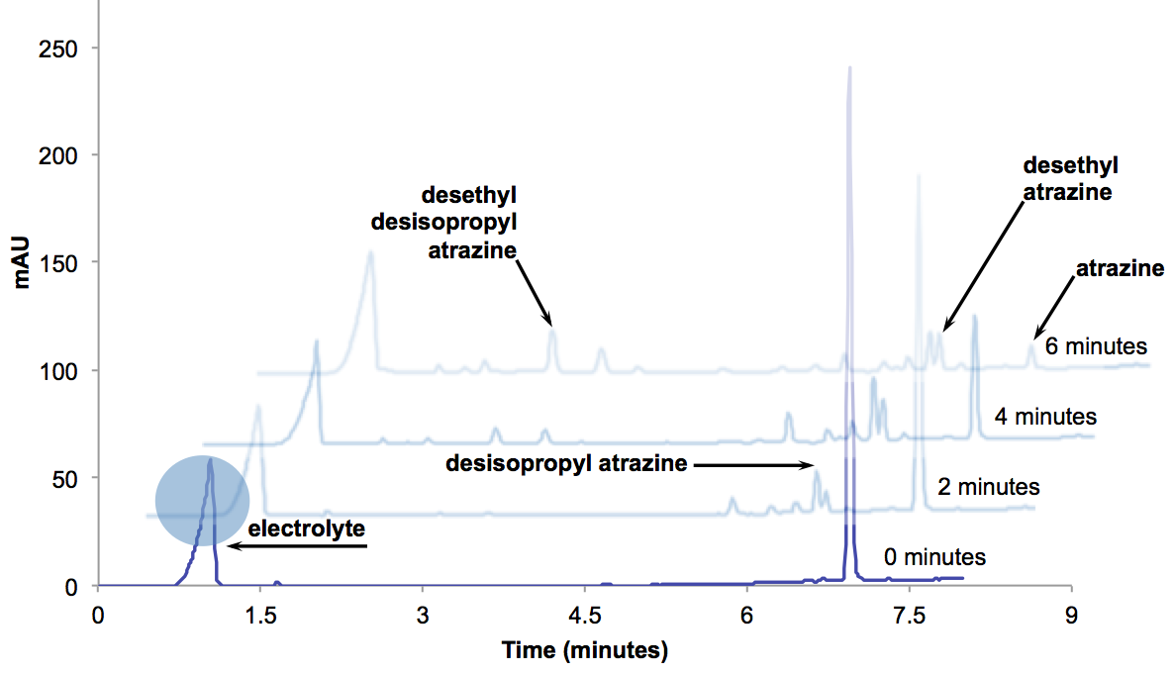
Figure 4. HPLC chromatograms for degradation of atrazine with ozonation/electrolysis (10mA/cm²; pH=7 with 5 mM phosphate buffer and 28 mM Na₂SO₄ + 10mg/L atrazine).

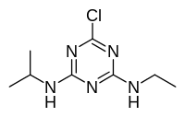

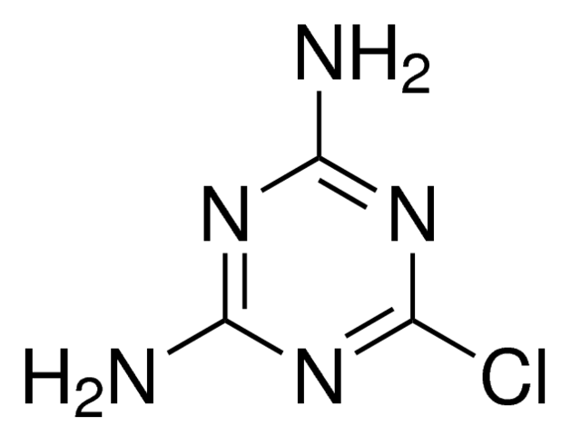
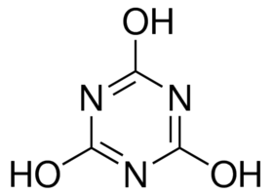
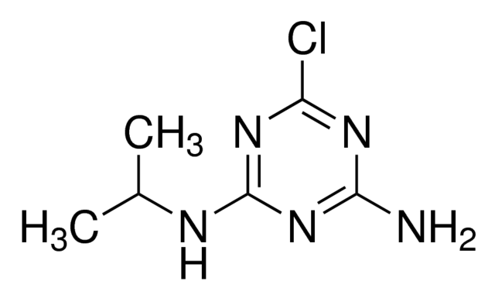
OH
O₃ / OH
O₃ / OH
O₃ / OH
O₃ / OH

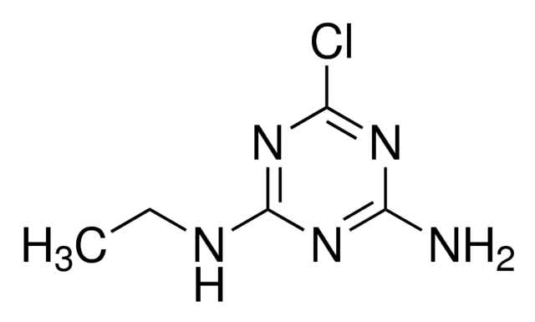

OH

[CO₂, H₂O, N₂, and Cl₂]

Figure 5. Proposed overall reaction pathways for the degradation of atrazine by the electrolysis-O₃ process.

Further inspection of the degradation of atrazine was studied at time intervals in which atrazine concentration was at 10% of its initial concentration (90% degradation). This was done to more deeply analyze the pathway of each condition for electrolysis with BDD (Figure 6a-bottom), ozonation only (Figure 6b-middle), combined ozonation/electrolysis (Figure 6c-middle), and ozonation/electrolysis with the presence of MnO₂ (Figure 6d-top). Interestingly, electrolysis, though significantly slower, offers complete mineralization of atrazine. On the other hand, ozone alone and in combination with electrolysis yields similar products, such as DEA, DIA, and DDA. However, there are still significant concentrations of oxidation products that have yet to be identified, such as those present at t_{r}=6.03 and t_{r}=6.11 minutes, respectively. Additionally, oxidation with ozone depicts a predominant product yet to be identified (t_{r}=6.03 min). In future work, Quadrupole Time of Flight-Liquid Chromatography-Mass Spectrometry (QTOF-LC-MS) will be used to determine the identity of such products and help shed light on a more detailed reaction pathway for the degradation of atrazine. What Figure 6 also shows is that the presence MnO₂ (Figure 6a) provides no apparent changes to the reaction mechanism. While reports suggest that the higher oxides provide a nucleophilic active center for a favorable interaction with the electrophilic ozone molecule, this chromatographic data that the reaction conditions provided, such as the sulfate electrolyte, do not provide the higher oxide of the metal to establish catalytic adsorption of ozone.^{21, 22}

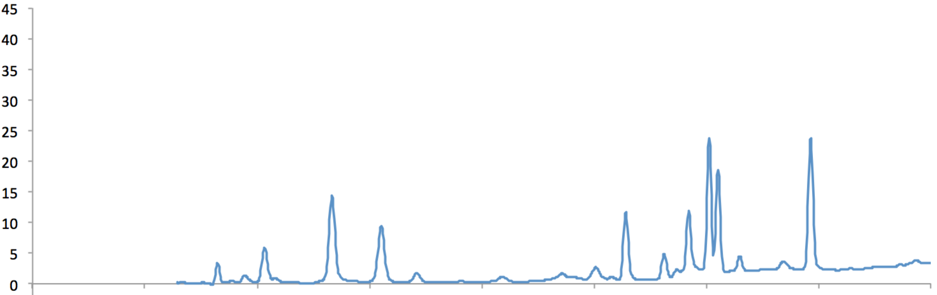

(a)
(b)
(c)
(d)

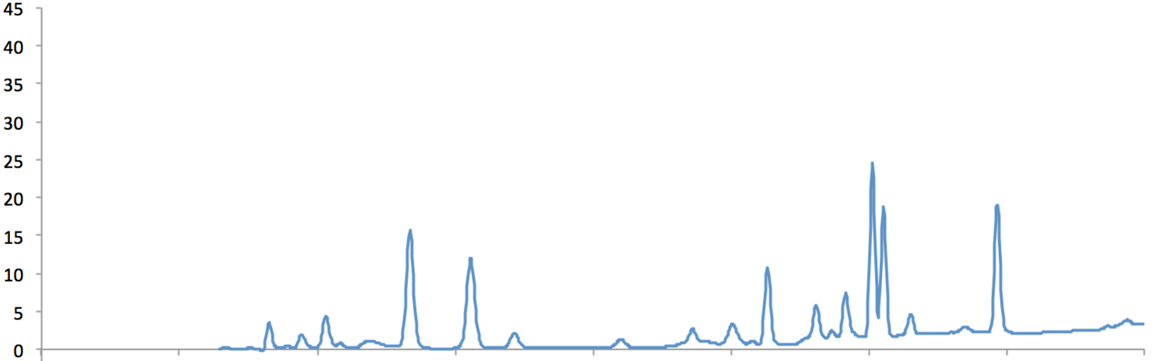

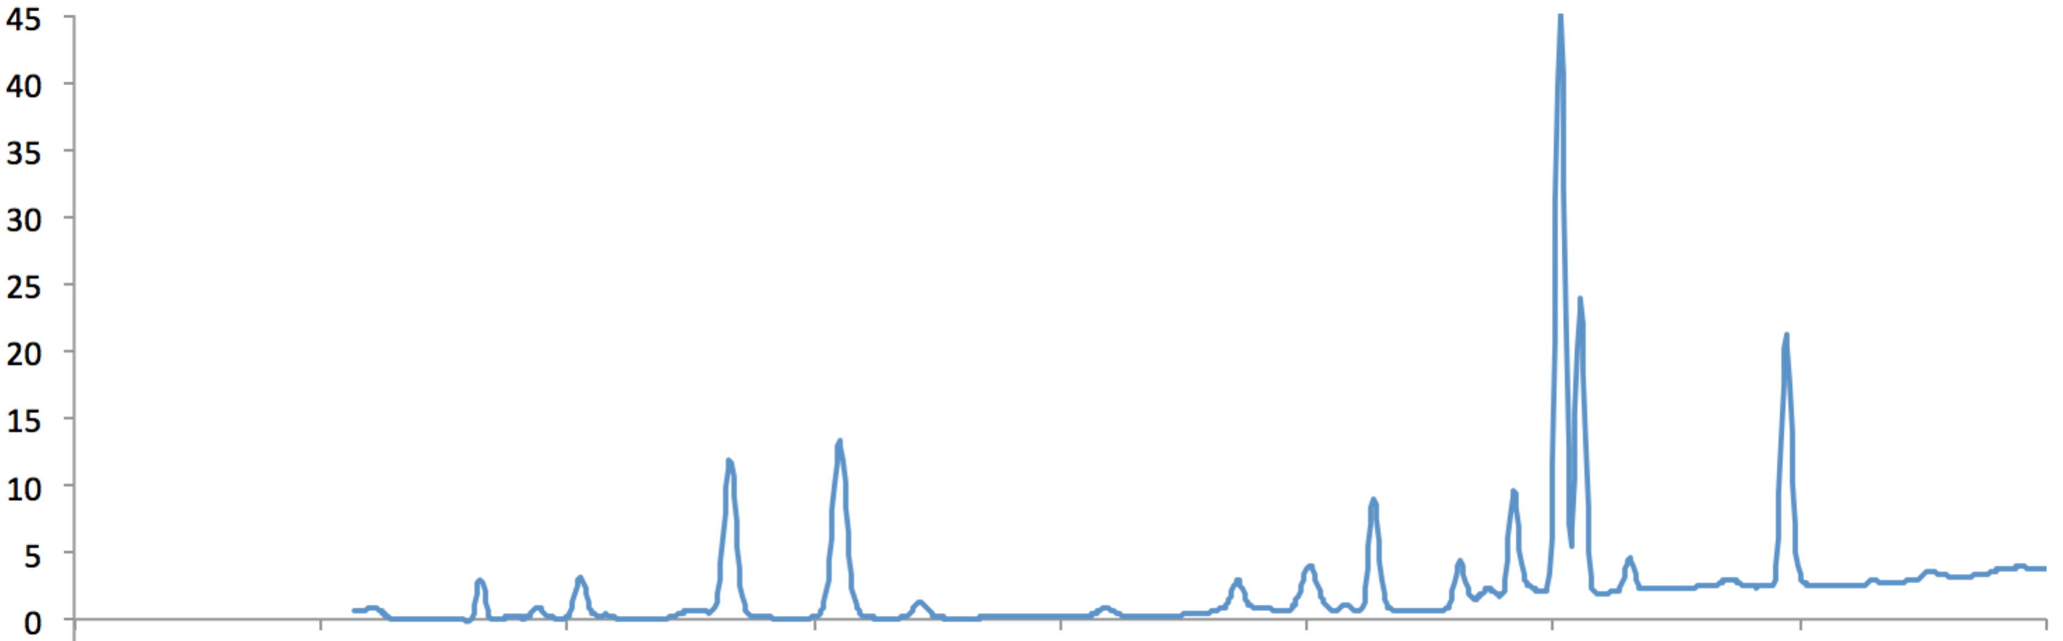

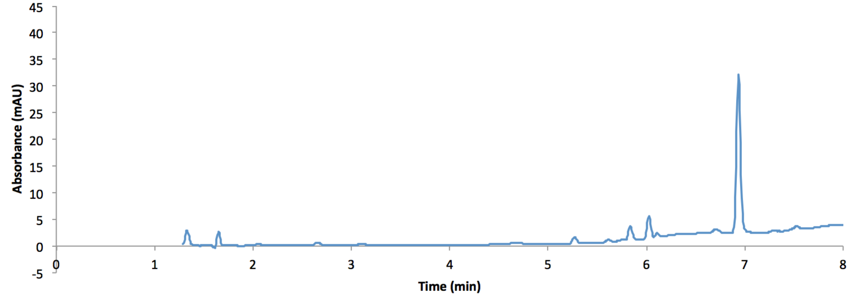 Figure 6. HPLC chromatograms for oxidation products atrazine with at sampling times with approximately 90% atrazine degradation: (a) electrolysis at 10mA/cm², (b) ozonation, (c) combined ozonation/electrolysis at 10mA/cm², and (d) combined ozonation/electrolysis + 10 mg/L of MnO₂ all conducted at pH=7 with 5 mM phosphate buffer, 28 mM Na₂SO₄ + 10mg/L atrazine. Retention times zero to time 1.2 minutes were omitted for sulfate electrolyte to maximize resolution of oxidation products.

Summary.
Atrazine degradation was optimal at a current density of 10.0mA/cm² with a pseudo-zero order reaction rate of, with respect to atrazine. At current densities >20.0mA/cm², the ozonation/electrolysis synergism was less favored due to ozone stripping and current-limited mass transport. The application of MnO₂ as a suspended solid and as an anode and cathode, demonstrated limited to no improvement to the adsorption of and, subsequent, oxidation of atrazine by ozone. These findings are supported with featureless voltammograms of MnO₂-coated electrodes and chromatographic analysis, as well as normalized degradation of atrazine over time and residual ozone concentration. While studies have suggested higher oxides influence the ozonation pathway of ozonation/electrolysis synergism, this report uncovers manganese dioxide’s oxidant competition with ozone and no apparent change or improvement to the ozonation/electrolysis pathway to oxidize atrazine.

AUTHOR INFORMATION
*Corresponding Author. Email: margaret.kupferle@uc.edu

Notes:
The authors declare no competing financial interest.

ACKNOWLEDGEMENTS
This project was partially supported by the Research Experience for Teachers (RET) program funded by the National Science Foundation, Grant ID# EEC-1404766.

REFERENCES
1. Ding, G. and Bao, Y. Revisiting pesticide exposure and children's health: Focus on China. Sci. Total Environ. 2014, 472, 289-295.
2. <br /> Public Health Statement for Atrazine. 2003<br /><br />; Agency for Toxic Substances and Disease Registry: Atlanta, Georgia; http://www.atsdr.cdc.gov/phs/phs.asp?id=336&tid=59.
3. Roy, J.R.; Chakraborty, S.; Chakraborty, T.R. Estrogen-like endocrine disrupting chemicals affecting puberty in humans--a review. Med. Sci. Monit. 2009, 15 (6), RA137-45; 869670 [pii].
4. Qiu, C.; Yuan, S.; Li, X.; Wang, H.; Bakheet, B.; Komarneni, S.; Wang, Y. Investigation of the synergistic effects for p-nitrophenol mineralization by a combined process of ozonation and electrolysis using a boron-doped diamond anode. J. Hazard. Mater. 2014, 280, 644-653.
5. Shinomiya, T.; Gupta, V.; Miura, N. Effects of electrochemical-deposition method and microstructure on the capacitive characteristics of nano-sized manganese oxide. Electrochim. Acta 2006, 51 (21), 4412-4419; http://dx.doi.org/10.1016/j.electacta.2005.12.025.
6. Yang, L.; Hu, C.; Nie, Y.; Qu, J. Catalytic ozonation of selected pharmaceuticals over mesoporous alumina-supported manganese oxide. Environ. Sci. Technol. 2009, 43 (7), 2525-2529.
7. Wu, M.; Snook, G.A.; Chen, G.Z.; Fray, D.J. Redox deposition of manganese oxide on graphite for supercapacitors. Electrochemistry Communications 2004, 6 (5), 499-504; http://dx.doi.org/10.1016/j.elecom.2004.03.011.
8. Hu, C. and Tsou, T. Ideal capacitive behavior of hydrous manganese oxide prepared by anodic deposition. Electrochemistry Communications 2002, 4 (2), 105-109.
9. Bader, H. and Hoigné, J. Determination of ozone in water by the indigo method. Water Res. 1981, 15 (4), 449-456.
10. Anonymous <br />4500-O₃ B. Indigo Colorimetric Method, In Standard Methods for the Examination of Water and Wastewater, 21st ed.; Anonymous ; American Public Health Association: 2005; pp. 4-144-4-145.
11. Gordon, G.; Pacey, G.E.; Cooper, W.J.; Rice, R.G. —Review Paper—Current State-Of-The-Art Measurements Of Ozone In The Gas Phase And In Solution. 1988, .
12. Selman, J.R. and Tobias, C.W. Mass-transfer measurements by the limiting-current technique. Adv.Chem.Eng 1978, 10 (21), 1-318.
13. Vera, Y.M.; de Carvalho, R.J.; Torem, M.L.; Calfa, B.A. Atrazine degradation by in situ electrochemically generated ozone. Chem. Eng. J. 2009, 155 (3), 691-697.
14. Naydenov, A. and Mehandjiev, D. Complete oxidation of benzene on manganese dioxide by ozone. Applied Catalysis A: General 1993, 97 (1), 17-22.
15. Malpass, G.R.P.; Miwa, D.W.; Machado, S.A.S.; Olivi, P.; Motheo, A.J. Oxidation of the pesticide atrazine at DSA® electrodes. J. Hazard. Mater. 2006, 137 (1), 565-572; http://dx.doi.org/10.1016/j.jhazmat.2006.02.045.
16. Feng, Y. and Li, X.Y. Electro-catalytic oxidation of phenol on several metal-oxide electrodes in aqueous solution. Water Res. 2003, 37 (10), 2399-2407.
17. Mabbott, G.A. An introduction to cyclic voltammetry. J. Chem. Educ. 1983, 60 (9), 697.
18. Lipkowski, J. and Ross, P.N. Electrocatalysis. John Wiley & Sons: 1998.
19. Trasatti, S. Electrocatalysis: understanding the success of DSA®. Electrochim. Acta 2000, 45 (15), 2377-2385.
20. Foti, G.; Gandini, D.; Comninellis, C. Anodic oxidation of organics on thermally prepared oxide electrodes. Current topics in Electrochemistry 1997, 5 (GGEC-ARTICLE-1997-002), 71-91.
21. Li, W.; Gibbs, G.; Oyama, S.T. Mechanism of ozone decomposition on a manganese oxide catalyst. 1. In situ Raman spectroscopy and ab initio molecular orbital calculations. J. Am. Chem. Soc. 1998, 120 (35), 9041-9046.
22. Andreozzi, R.; Insola, A.; Caprio, V.; Marotta, R.; Tufano, V. The use of manganese dioxide as a heterogeneous catalyst for oxalic acid ozonation in aqueous solution. Applied Catalysis A: General 1996, 138 (1), 75-81.

